User’s Manual

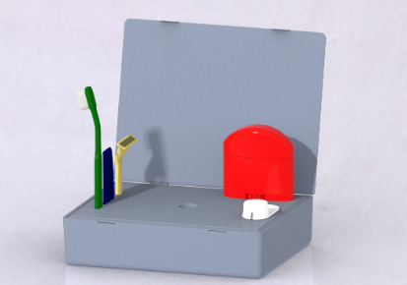

Please refer to the user’s manual for information about the product

**Table of Contents:**

**Assembly**…………………………………………………………………………3

**Use and Maintenance**………………………………………………………….. 4

**Warranty Information**………………………………………………………….5

**Service Center Information**…………………………………………………….5

Assembly

Our toiletries case (Figure 1) comes with two primary components and conveniently comes pre-assembled from the factory. The product assembly consists of the case (Colored red in Figure 1.) and stand (Colored blue in Figure 1.). 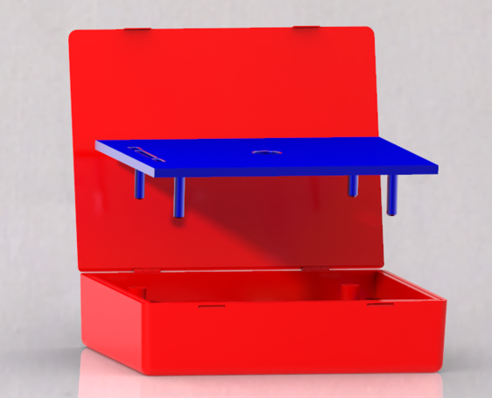

Figure 1.

The stand slides into the four holes in the main case and, once assembled, your toiletry case is ready to go! The holes that the stand slots into can be seen in Figure 2.

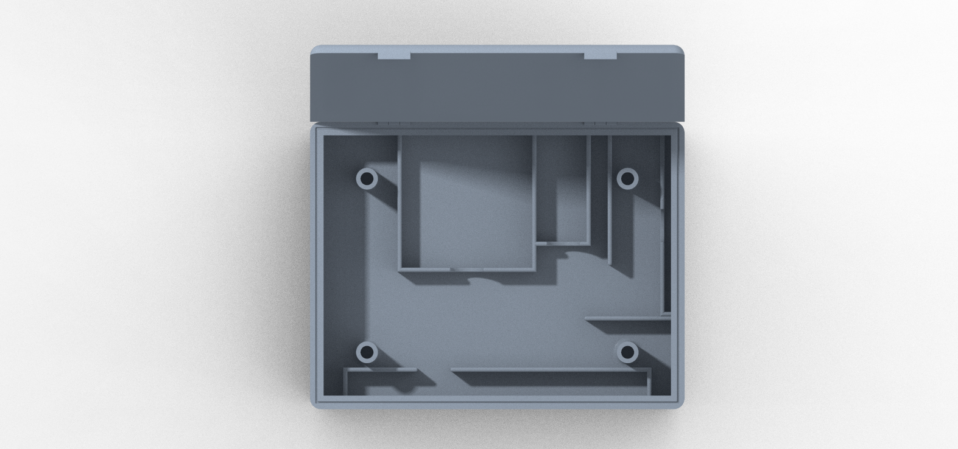

Figure 2.

Use and Maintenance

Our case will keep your items safe and secure during your travels. Each item has a slot in the case that prevents it from shifting during travel. Notches in the ribs allow easy access to your items whenever you need them. Figure 3 shows how each item fits in the case.

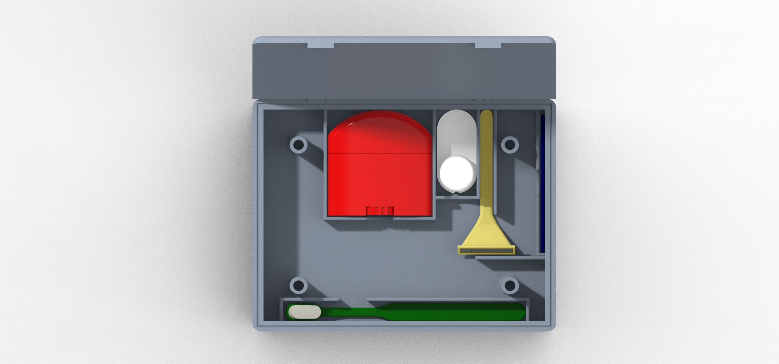

Figure 3.

Once you reach your location, you can place your items on the removable tray to stay organized. Items such as toothbrushes, razors and combs can be placed in the designated slots for safe keeping. Other essentials can be placed on the open area of the tray. Figure 4 shows the tray being used.



Figure 4.

Very little maintenance is required for this case but in order to ensure proper operation it is best to keep the case clean. The case can simply be cleaned with soap and water, do not dish wash. Make sure the case is completely dry before using it again to prevent mold from forming.

Warranty Information

If your product is damaged in shipping, or you receive a defective unit, you may contact our service center to request a replacement.

If your product breaks within the first 90 days under normal use case conditions, you may contact our service center to request a replacement.

Service Center Information

Contact us:

Jake Kaupang

Email- jkaupang@uncc.edu

Hayden Kupka

Email- hkupka@uncc.edu

Davis Parker

Email- dparke75@uncc.edu